NATIONAL UNIVERSITY OF MODERN LANGUAGES
lab reports

SUBMITTED BY:
ZULQARNAIN HASSAN

SUBMITTED TO:
Sir M.BILAL SHAHNAWAZ
Subject: ……………………………………….. OOP
Roll No: ………………………………………… 21379
Department: …………………………………. Software engineering
Section: …………………………………………. BSSE-II-A-afternoon

LAB 1:
Date: 13 September 2022
Lab Objectives:
In the first lab following topics are done.
- Installation of JDK: the java development kit is a distribution of java technology by oracle corporation. It implements the java virtual machine specification and provide the standard edition if the java application programming interface.
- Software development kit (SDK):
  - Libraries: also known as application program interface these files are previously written classes and method that contain some common functionality.
  - Compiler: the program that translate files written in java language into binary files in order to execute them.
  - Interpreter: some programing languages do not compile the source code file into directly executable form, but they instead compile it into partially compile file that could be executed by a program called interpreter.

LAB TASKS:
Task 1:
Write a code to print your name and roll number.
class firstprogram
{
public static void main(String abc[])
{
System.out.println(“Zulqarnain Hassan”);
System.out.println(“21379”);
}
}
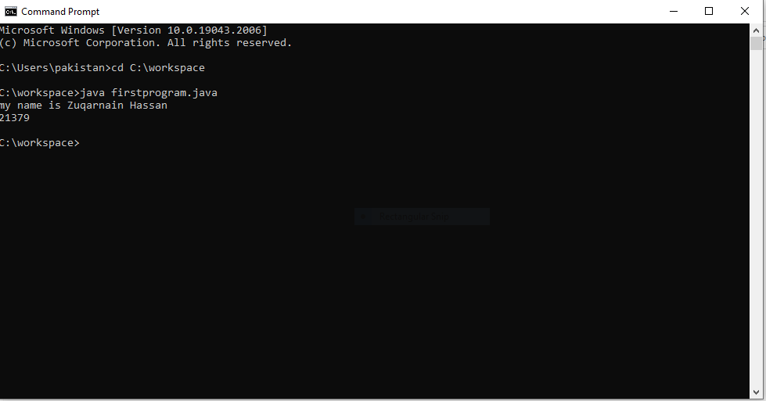
Task 2:
Can we save this code with some other name like testing.java rather then with the class name? try it.
class firstprogram
{
public static void main(string abc [])
{
System.out.println(“my first java program”);
}
}
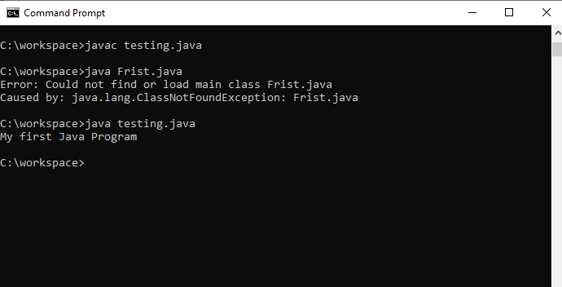
Task 3:
Run the following code and see the result.
class program2
{
public static void main(String args [])
{
int a,b,c;
a=3;
b=4;
c=a+b;
System.out.println(“sum of two number =”+c);
}
}
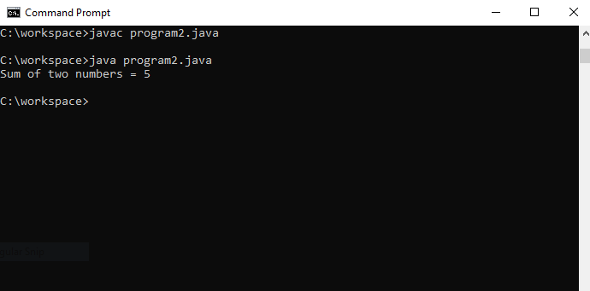
Task 4:
Run the following code by saving it firstly with name abc.java and then with bcd.java and check the output.
class abc
{
Public static void main(String args [])
{
System.out.println(“hello world”);
}
}

On saving with name as abc.java:
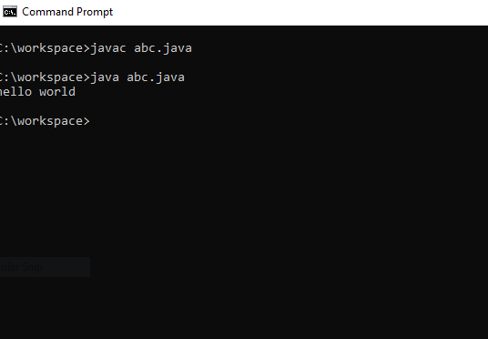

On saving with name as bcd.java:
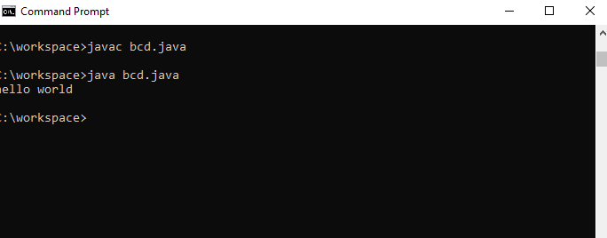

LAB 02:
Date: 20 September 2022

Objectives: After the lab, students will be able to.
- Use the Eclipse IDE for java program development.
- Run a simple java program in Eclipse.
- Create a simple java program in Eclipse.

To write code and make classes you have to create a new project in eclipse.
When the project is created with a name then create a class after that you can now see the editor where you can write your code.

LAB TASKS
Task 1:
Create a Java program and write the following statements one by one to find the difference between print() and println() methods. Closely examine how the outputs differ.
1.
System.out.println("Which one is your favourite programming language?");
System.out.print("java");
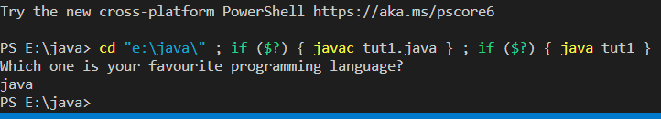

2.
System.out.println("Which one is your favourite programming language?");
System.out.print("java");
System.out.print("java");

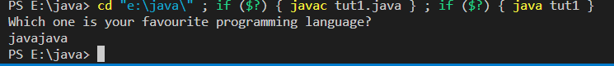

3.
System.out.println("Which\n one\n is\n your\n favourite\n programming\n language?");
System.out.println("java");

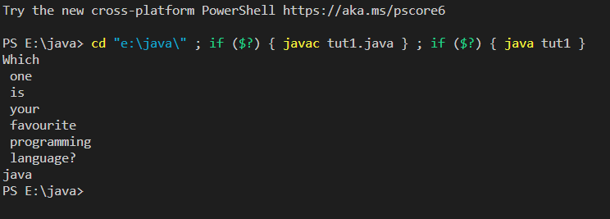

Task 2:
Calculate the average, sum & difference of 876 &767. First store these values in variables and then calculate the result.
class tut1
{
public static void main(String abc[])
{
int a,b,c;
a=876;
b=767;
c=a+b;
System.out.println(“sum=”+c);
c=c/2;
System.out.println(“average=”+c);
c= a-b;
System.out.println(“difference=”+c);

}
}

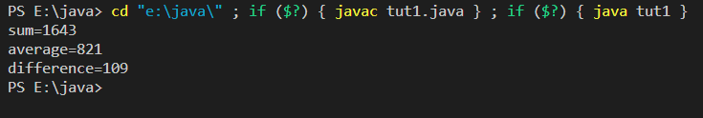

Task 3:
Calculate the area of circle when radius is 9.8 cm. (A=πr²)

class tut1
{
public static void main(String abc[])
{
float r=9.8F,A;
A=3.14F*r;
System.out.println(“Area= ”+A);
}
}
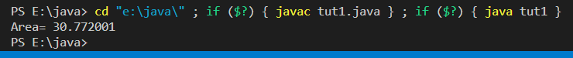

Task 4:
Write a program to declare three variables; a, b, and c. Assign some values to a and b and save their sum in variable c. Now, print the sum.

class tut1
{
public static void main(String abc[])
{
Int a,b,c;
a=23;
b=43;
c=a+b;
System.out.println(“Sum =”+c);
}
}
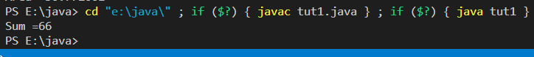

LAB 03:
Date: 27 September 2022

Lab Objectives:
After this lab, the students should be able to
- Use command line arguments in Java.
- Take input from the user and display output.

Example 1:

class Example {
public static void main(String[] args) {

System.out.println(“your first argument is ”args [0]);
}
}

Example 2:
class showArgs {
public static void main(String[]args)
{
for (int i=0;i<args.length; i++)
{
System.out.println(“argument ” + i +”=”+args[0]);
}
}
}
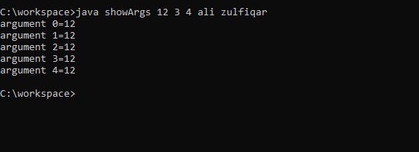

Example 03

This program demonstrates the use of Scanner Class.
Import java.util.*;
Class UserInputDemo {
Public static void main(String[] args)
{
Scanner sc= new Scanner(System.in);
System.out.print(“enter first number”);
int a= sc.nextInt();
System.out.print(“enter second number”);
int b= sc.nextInt();
System.out.print(“enter third number ”);
int c= sc.nextInt();
int d=a+b+c;
System.out.println(“Total=”d);

}

}

Example 04:
Example of String Input from user
import java.util.*;
class InputDemo {

public static void main(String[]args)
{
Scanner sc=new Scanner(System.in);
System.out.print(“enter a string”);
String str =sc.nextLine();
System.out.print(“you have enter ”+str);

}

}

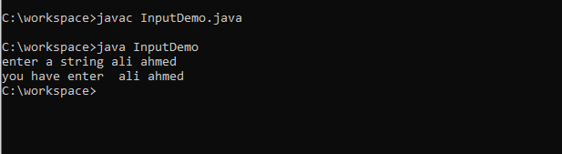

LAB TASKS
Task 0:
Pass username and password in command line arguments and display them on the console.
public class tut2 {
public static void main(String arg[])
{
// Scanner data=new Scanner(System.in);
String name="Zulqarnain Hassan";
long passward=12345678901L;
System.out.println("your name is "+name);
System.out.println("your passward is "+passward);

}

}
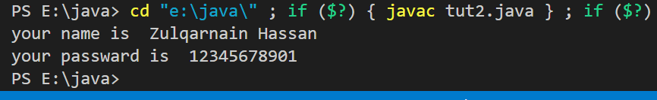
Task 1:
Take your name and registration number as input from user and generate the following output. (Note: Output must be similar as shown here)
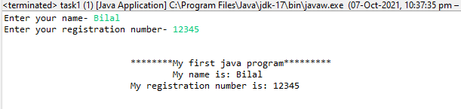
import java.util.*;
public class tut3 {
public static void main (String arg[])
{
Scanner data=new Scanner(System.in);
System.out.println("Enter your name ");
String name=data.nextLine();
System.out.println("Enter your registration number ");
int reg=data.nextInt();
System.out.println(" *********my first java program is*********");
System.out.println(" My name is "+name);
System.out.println(" My registration number is "+reg);
}

}
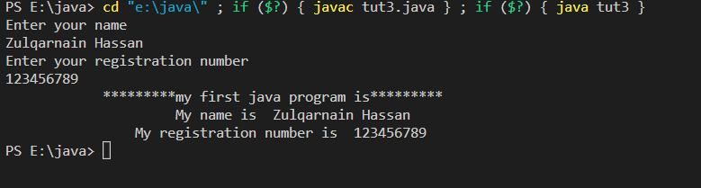
Task 2:
Take radius of circle from user and calculate area and circumference of circle.
import java.util.Scanner;
public class tut4 {
public static void main(String arg[])
{

Scanner data=new Scanner(System.in);
System.out.print("Enter the radius of the circle: ");
float rad=data.nextFloat();
float Area=3.14F*rad*rad;
float Cir=2*3.14F*rad;
System.out.println("Area is: "+Area);
System.out.println("circumfarance is: "+Cir);
}

}
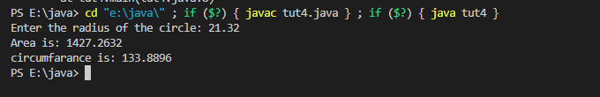
Task 3:
Write a program to convert temperature in Fahrenheit to temperature in Celsius
C=(F-32)*5/9; // temperature in Fahrenheit will be entered by user
import java.util.*;
public class tut5 {
public static void main(String[] args) {

Scanner data=new Scanner(System.in);
System.out.print("Enter temperatur in farenheit:");
int f=data.nextInt();
float c=(f-32)*5/9f;
System.out.println("the temperatur in celsius is: "+c);

}

}
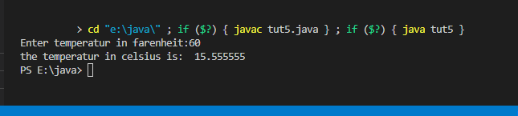
Task 4:
Take three numbers from user and calculate their average. Output should be like this.
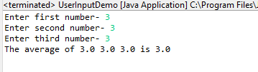
import java.io.DataInput;
import java.util.Scanner;

public class tut6 {
public static void main(String[] args) {
Scanner data=new Scanner(System.in);
System.out.println("Ener first number: ");
int a=data.nextInt();
System.out.println("Ener second number: ");
int b=data.nextInt();
System.out.println("Ener third number: ");
int c = data.nextInt();
float d=(a+b+c)/3;
System.out.println("Ener average of : "+a+" "+b+" "+c+" is "+d);
}

}
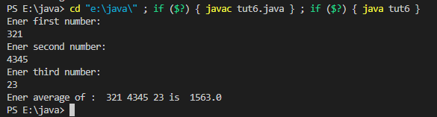
Task 5:
Write a program to convert kilometers into meters where user will input distance in kilometer and the program will convert distance into meters
import java.io.DataInput;
import java.util.Scanner;

public class tut6 {
public static void main(String[] args) {
Scanner data=new Scanner(System.in);
System.out.println("Ener distance in kilometer: ");
float a=data.nextFloat();
float d=a*1000;
System.out.println("distace in meter : "+d);
}

}
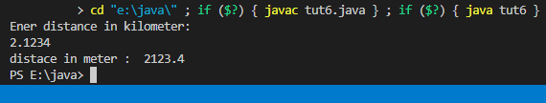

Lab #06
Objectives
- Implement Arrays in Java
- Implement Control Structures in Java
- Use decision control structures (if, else, switch)
- Use repetition control structures (while, do-while, for)
- Use branching statements (break, continue, return

Arrays:
Arrays are special data types that let us store a specified number of variables from the same type using one variable name.
Declaring and using an array in Java is similar to the declaration of any variable; you have to specify the data type and name, in addition to this, you have also to specify the length of the array before using it.
To initialize the array, use new keyword and specify the length.
DataType array-variable[ ]= new DataType[length];
Example 01:
public class multidimensionalArray {
public static void main(String[] args) {
//declaring and initializing 2D array
int arr[][]={{1,2,3},{2,4,5},{4,4,5}};
//printing 2D array
for(int i=0;i<3;i++){
for(int j=0;j<3;j++){
System.out.print(arr[i][j]+" ");
}
System.out.println();
}
}
}
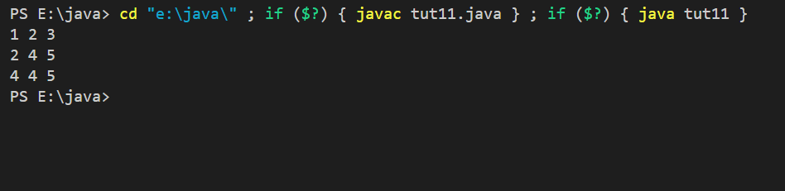

Example 02:
public class ifelseExample {
public static void main(String[] args) {
int month=4;
String season;
if (month==12 || month==1 || month==2)
season="winter";
else if(month==3 || month==4 || month==5)
season="spring";
else if(month==6 || month==7 || month==8)
season="summer";
else if(month==9 || month==10 || month==11)
season="autumn";
else
season="Invalid Month";

System.out.println("April is in the " + season + ".");
}
}
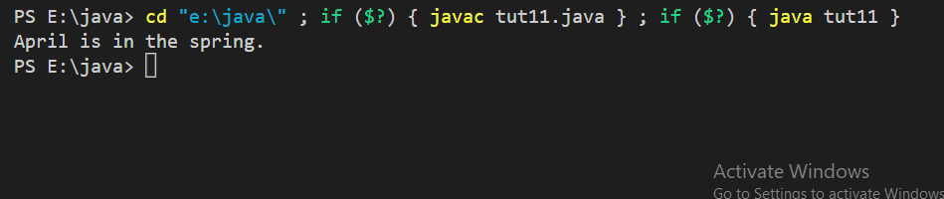

Example 03:
public class switchExample {
public static void main(String[] args) {
for(int i=0;i<6;i++)
switch(i){
case 0:
System.out.println("i is zero.");
break;
case 1:
System.out.println("i is one.");
break;
case 2:
System.out.println("i is two.");
break;
case 3:
System.out.println("i is three.");
break;
default:
System.out.println("i is greater than 3.");
}
}

}
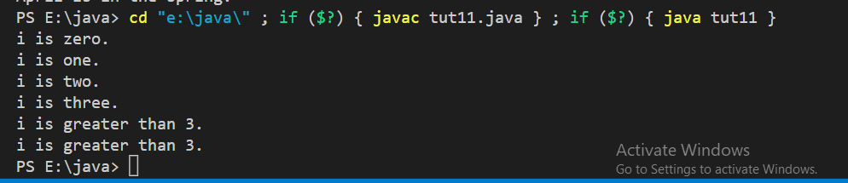

Example 04:
public class whileExample {
public static void main(String[] args) {
int n=10;

while(n>0)
{
System.out.println("tick" +n);
n--;
}
}
}
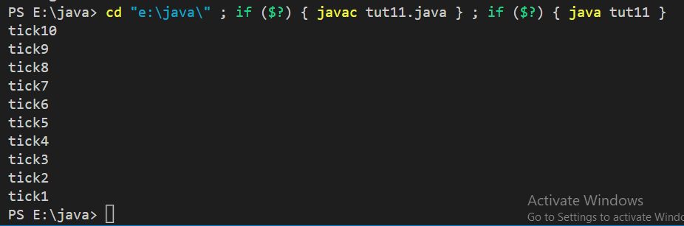

Example 05:
public class dowhileExample {
public static void main(String[] args) {
int n=10;
do{
System.out.println("tick" +n);
n--;
}while(n>0);

}
}

public class forExample {
public static void main(String[] args) {
for (int n=10;n>0;n--)
System.out.println("tick" +n);
}
}


Example 06:
public class breaknested {
public static void main(String[] args) {
for(int i=0;i<3;i++)
{
System.out.print("Pass" +i+ ":");
for(int j=0;j<100;j++)
{
if(j==10) break;
System.out.print(j + " ");
}
System.out.println();
}
System.out.println("Loops complete. ");
}
}
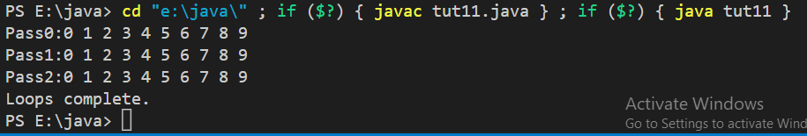

Example 07:
public class continueExample {
public static void main(String[] args) {
for(int i=0;i<10;i++)
{
System.out.print(i + " ");
if(i%2 == 0) continue;

System.out.println("");
}
}
}
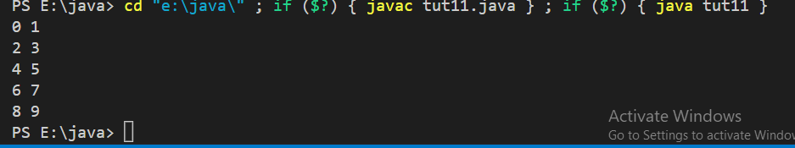

Example 08:

import java.util.Scanner;

public class returnExample {
public static void main(String[] args) {
int num1, num2;
Scanner data = new Scanner(System.in);

System.out.println("Enter 1st number");
num1 = data.nextInt();
System.out.println("Enter 2nd number");
num2 = data.nextInt();
data.close();
total(num1,num2);
}

public static void total(int numx, int numy){
int sum=0;
sum=numx+numy;
if(sum==0)
return ;
System.out.println("Sum of 2 number:"+sum);

}

}
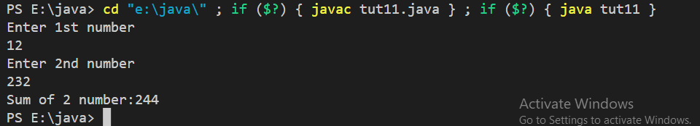

Lab Tasks:

Task 1:
Write a Java application that uses looping to print the following table of values:
Marks: 3

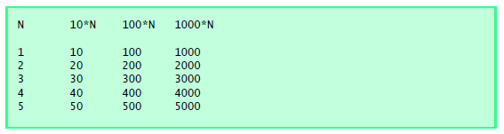

public class tut11 {
public static void main(String[] args) {

System.out.println("N 10*N 100*N 1000*N");

for(int i=1;i<5;i++)
{
System.out.println(i+" "+i*10+" "+i*100+" "+i*1000);
}

}

}
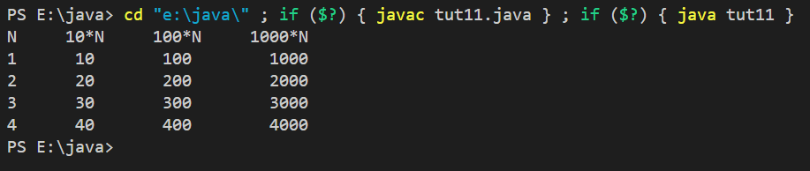

Task 2:
Write a program using while loop which calculate square of every number and then sum the squares of all numbers. Output should be like as shown below: Marks: 3

Output:

1
4
9
16
25
36
49
64
81
100
Total is 385

public class tut11 {
public static void main(String[] args) {
int i=1;
int sum=0;
while(i<=10)
{
System.out.println(i*i);
sum+=i*i;
i++;
}
System.out.println(sum);
}

}
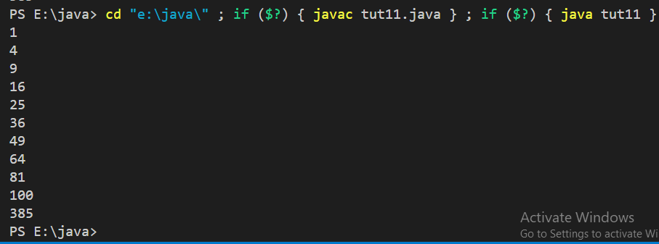

Task 3:
Write a test program that takes some values from user and stores in an array, and finds out the minimum value from an array.
import java.util.Scanner;

public class tut11 {
public static void main(String[] args) {
Scanner sc=new Scanner(System.in);
System.out.println("enter array size");
int n=sc.nextInt();
int [] array=new int [n];
int i=0;
System.out.println("Enter Arrays");
while(i<array.length)
{
array [i]=sc.nextInt();
i++;
}
int mini=array[0];
for(int j=1;j<array.length;j++)
{
if(mini>array[j])
mini=array[j];
}
System.out.println("the minimum value in the array is "+mini);
}

}
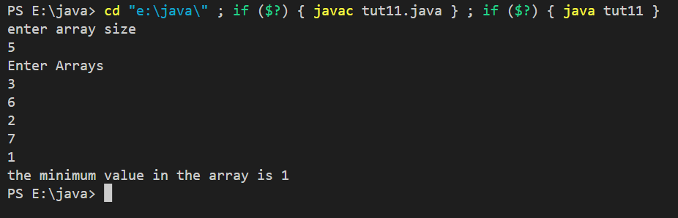

Task 4:
What does the following program print? Marks: 1

public class task3 {
public static void main(String[] args) {
int count = 1;
while ( count <= 10 ) {
System.out.println( count % 2 == 1 ? "****" : "++++++++" );
++count;
}
}
}

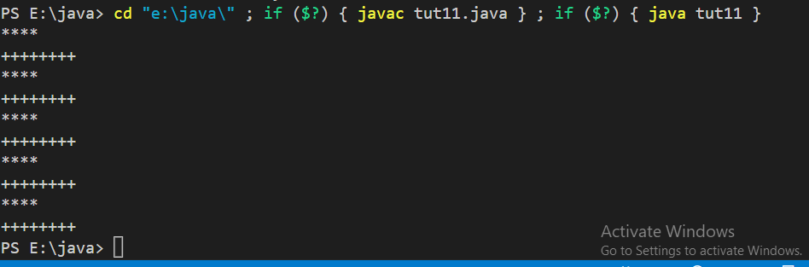

Lab 07

At the end of this lab, the students should be able to:
- Create class
- Create object
- Create method

Example:

class Box {
double width;
double height;
double depth;
}

public class boxText {
public static void main(String[] args) {
Box mybox=new Box();
double vol;

//assign values to mybox's instance variables
mybox.width=10;
mybox.height=20;
mybox.depth=15;

//compute volume of box
vol=mybox.width*mybox.height*mybox.depth;

System.out.println("Volume is " + vol);
}
}

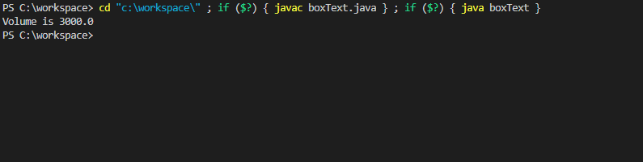
Example:

class Box {
double width;
double height;
double depth;

void volume(){
System.out.print("Volume is ");
System.out.println(width*height*depth);
}
}
//This class declares an instance of type Box.
public class boxTest {
public static void main(String[] args) {
Box mybox1=new Box();
Box mybox2=new Box();
double vol;

//assign values to mybox1's instance variables
mybox1.width=10;
mybox1.height=20;
mybox1.depth=15;

//assign different values to mybox2's instance variables
mybox2.width=3;
mybox2.height=6;
mybox2.depth=9;

//display volume of first box
mybox1.volume();

//display volume of first box
mybox2.volume();
}
}

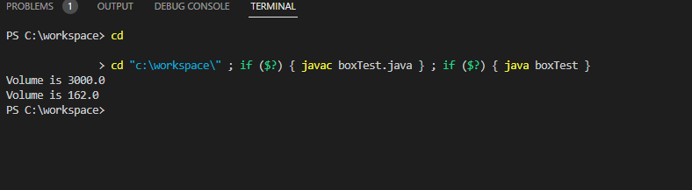

Lab Tasks:
Task 1: Marks:2.5

Define a class addressBook. It has three attributes name, address, and phone. It must have methods showName (), showAddress (), and showPhone() with return type void. Show methods will show the values of attributes only. Your name, address, & phone number to the class attributes can be set directly using syntax objectname.attributename. Make another class which encapsulates the main () method, make object of class adddressBook and print values of name, address and phone using these methods.

class AddressBook1 {
String name, address;
long phone;
void showname(){
System.out.println(name);
}
void showaddress(){
System.out.println(address);

}
void showphone(){
System.out.println(phone);

}
}
public class AddressBook {
public static void main(String[] args) {
AddressBook1 b=new AddressBook1();
b. name="ali khan";
b.address = "Islamabad G-7/4";
b.phone=012344534;
b.showaddress();
b.showname();
b.showphone();
}
String name, address;
long phone;
void showname(){
System.out.println(name);
}
void showaddress(){
System.out.println(address);

}
void showphone(){
System.out.println(phone);

}
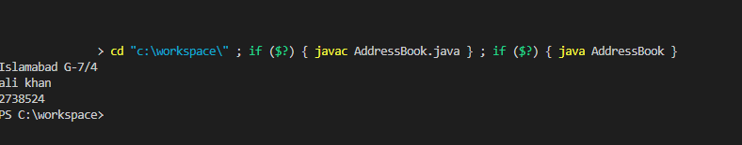
}

Task 2

Make a class Factorial which consists of a public parameterized method named factorial ( ). Factorial method must take an integer as a parameter and calculate its factorial. (Factorialmethod () can have return type void or a value returning method.)

public class Factorial {

public void factorial(int a)
{int b=a;
while(a>1)
{
b=b*(a-1);
a-=1;

}
System.out.println(b);
}
public static void main(String[] args) {
Factorial f=new Factorial();
f.factorial(4);
}
}

Lab 8: Tasks/Exercise
Lab 08
Program 01:-
package inheritance;
class Employee{
int salary = 10000;
}
class Programmer extends Employee{
int bonous = 5000;
public static void main(String[] args) {
// TODO Auto-generated method stub
Programmer P = new Programmer();
System.out.println("Salary of Employee is:"+P.salary);
System.out.println("Bonous of Employee is:"+P.bonous);
}
}
Output:-
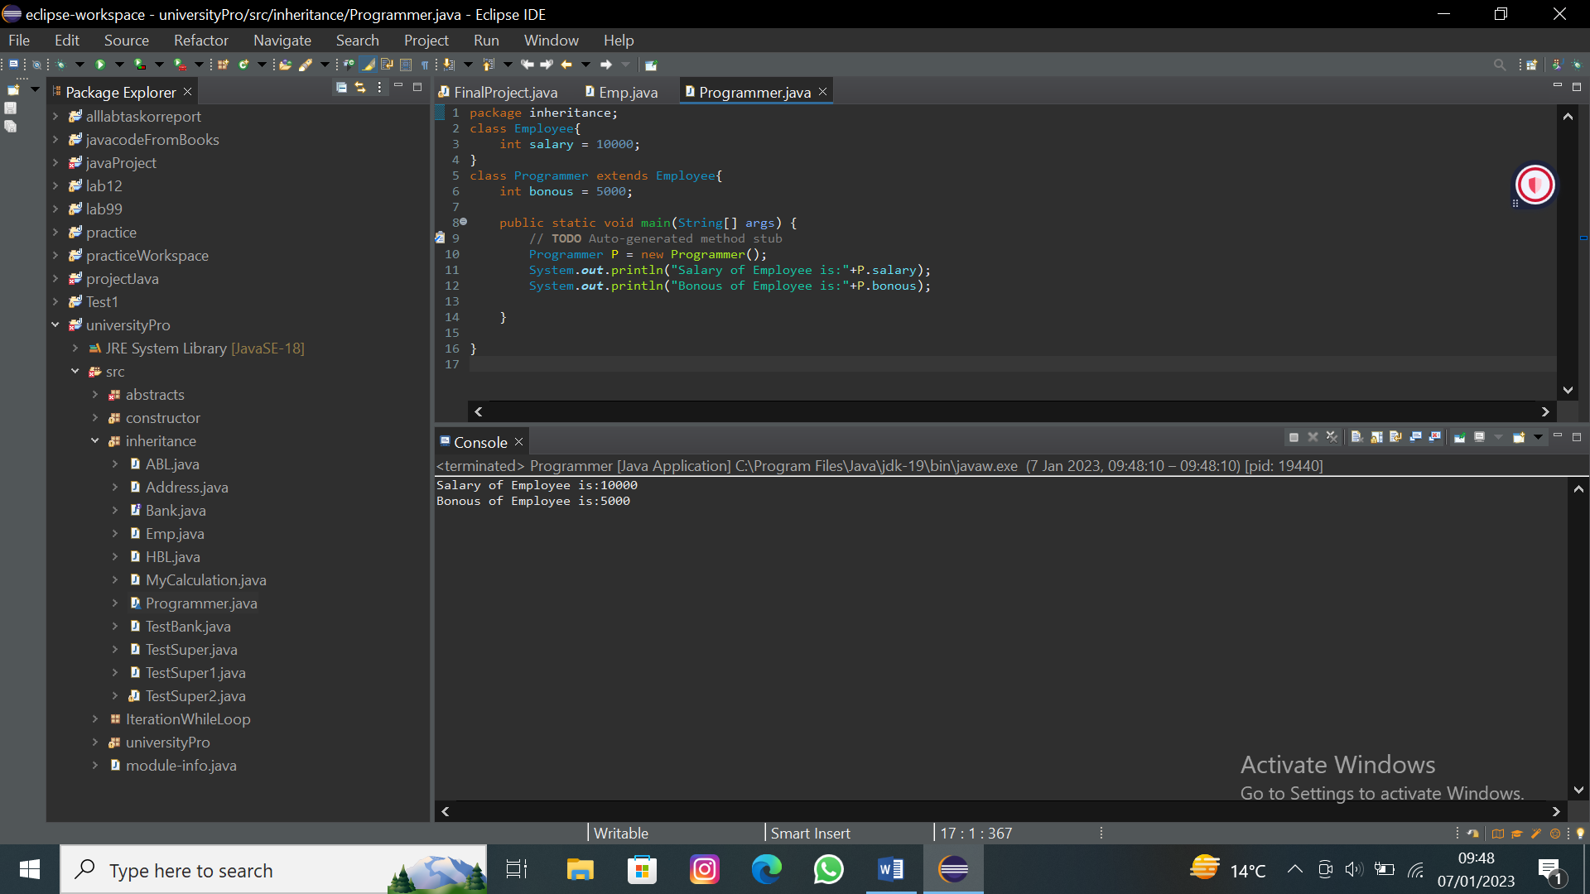
Program 02:-
package inheritance;
class Calculation{
public void Addition(int x ,int y) {
int z = x+y;
System.out.println("The addition of two number is: "+z);
}
public void Substraction(int x ,int y) {
int z = x-y;
System.out.println("The Substraction of two number is: "+z);
}
}
public class MyCalculation extends Calculation{
public void Multiplication(int x ,int y) {
int z = x*y;
System.out.println("The Multiplication of two number is: "+z);
}
public void Division(int x ,int y) {
int z = x/y;
System.out.println("The division of two number is: "+z);
}
public static void main(String[] args) {
// TODO Auto-generated method stub
int a = 9;
int b=6;
MyCalculation demo = new MyCalculation();
demo.Addition(a, b);
demo.Substraction(a, b);
demo.Multiplication(a, b);
demo.Division(a, b);
}
}
Output:-
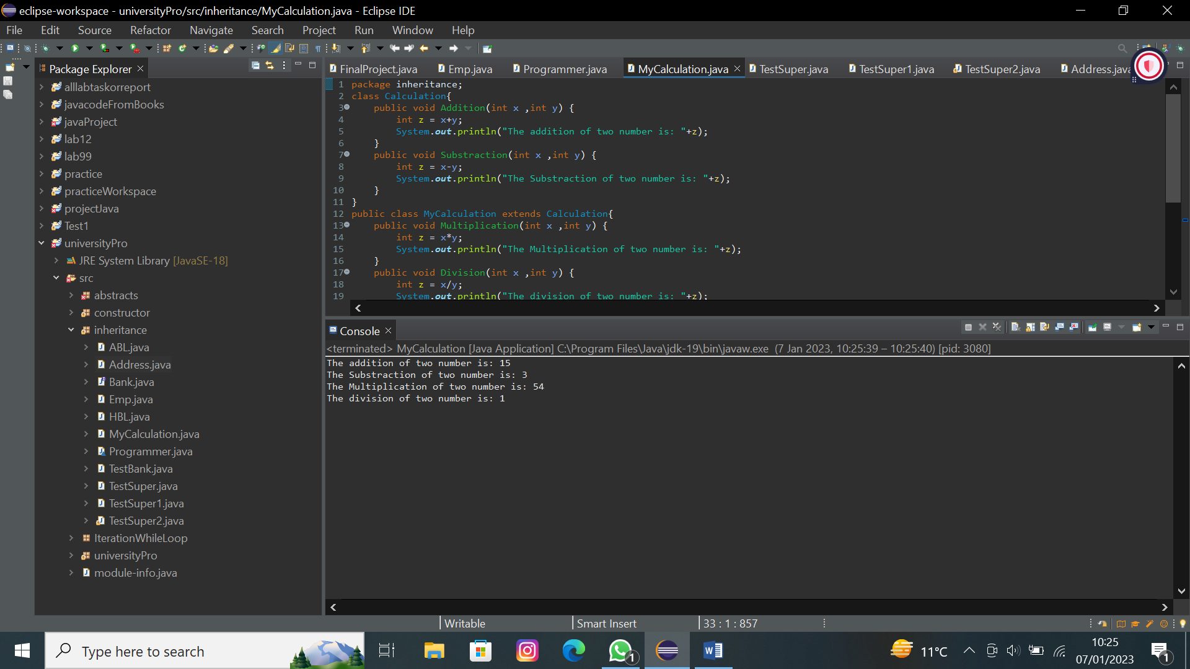

Program 03:-
To refer immediate parent class instance variable:
package inheritance;
class Animal{
String color ="White";
}
class Dog extends Animal{
String color = "black";
public void changeColor() {
System.out.println(color);
System.out.println(super.color);
}
}
public class TestSuper {
public static void main(String[] args) {
// TODO Auto-generated method stub
Dog D = new Dog();
D.changeColor();
}
}
Output:-
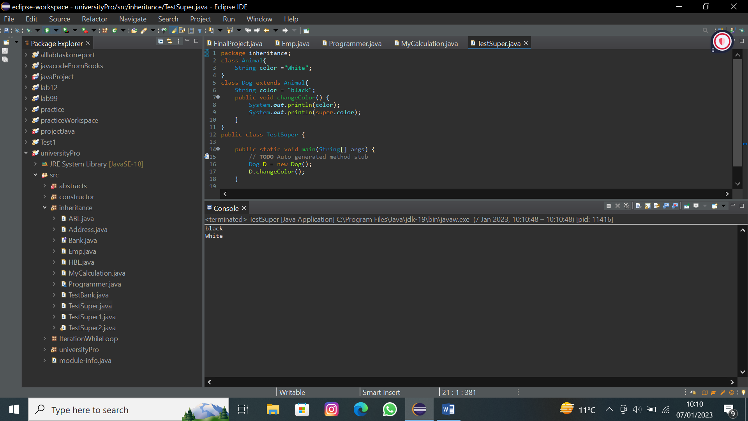
Program 04:-
To invoke parent class methods:
package inheritance;
class Animals{
public void eat() {
System.out.println("Animal is eating");
}
}
class Dogs extends Animals{
public void eat() {
System.out.println("Dog is eating");
}
public void Bark() {
System.out.println("Dog is barking");
}
public void work() {
eat();
Bark();
super.eat();
}
}
public class TestSuper1 {
public static void main(String[] args) {
// TODO Auto-generated method stub
Dogs d = new Dogs();
d.work();
}
}
Output:-
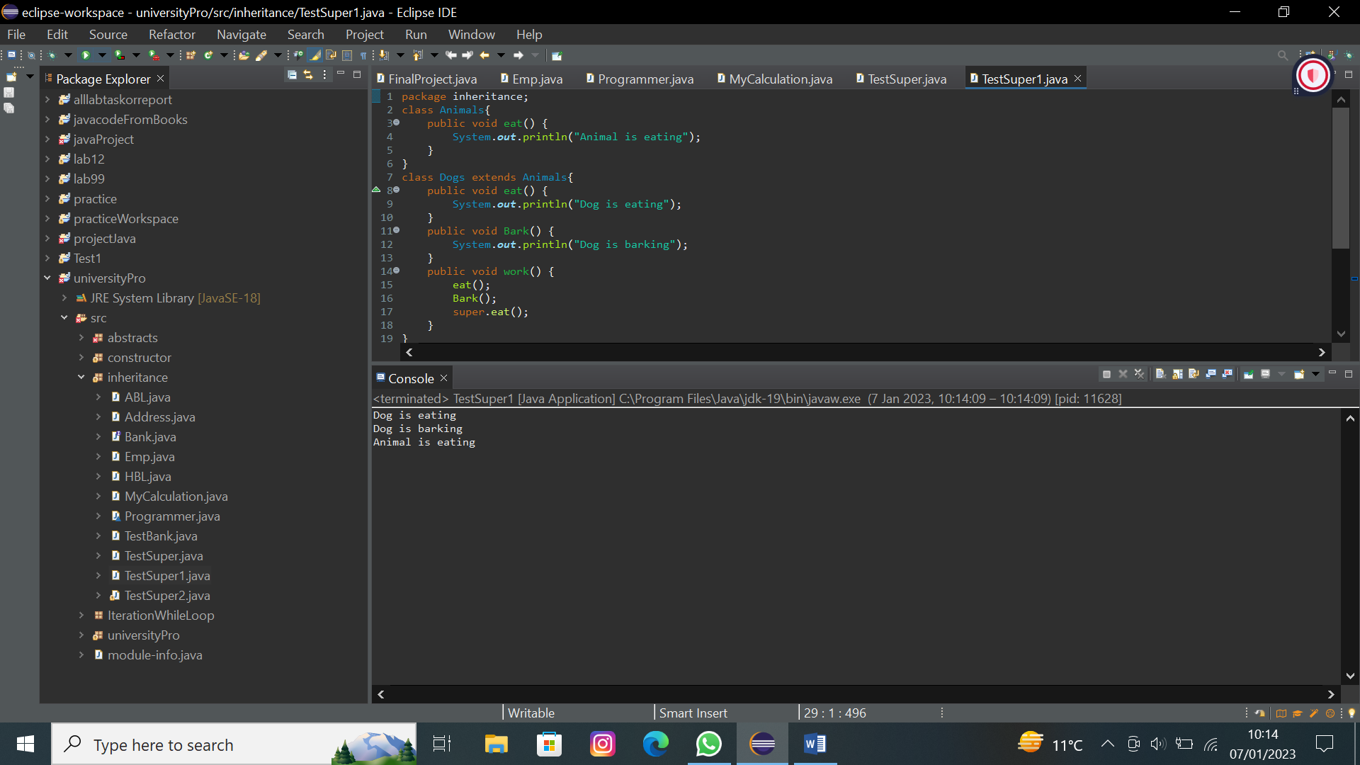

Program 05:-
To invoke parents class constructor
package inheritance;
class Animaless{
public Animaless() {
System.out.println("Animal is craeted");
}
}
class Dogess extends Animaless{
public Dogess(){
super();
System.out.println("Dog is creatsd");
}
}
public class TestSuper2 {
public static void main(String[] args) {
// TODO Auto-generated method stub
Dogess D1 = new Dogess();
}
}
Output:-
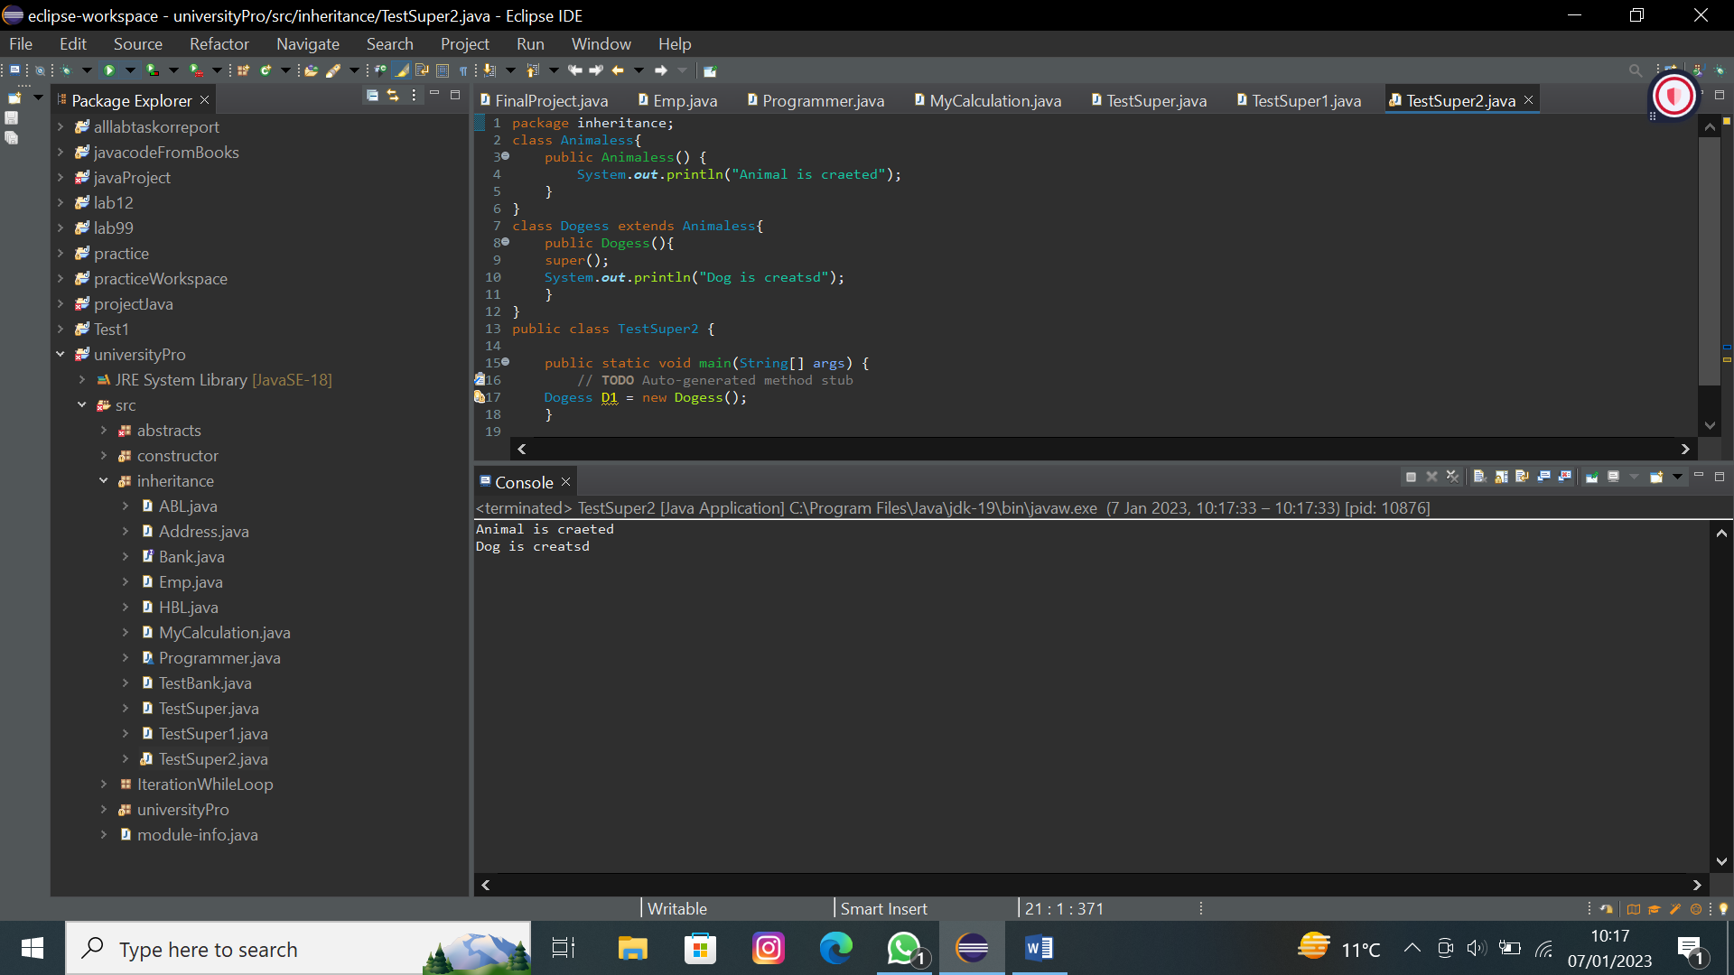
Program 06:-
Simple inheritance example:
package inheritance;
class Animal1{
void eat() {
System.out.println("Eating...");
}
}
class Dog1 extends Animal1{
void Bark() {
System.out.println("Barking...");
}
}
public class TestInheritance {
public static void main(String[] args) {
// TODO Auto-generated method stub
Dog1 D = new Dog1();
D.Bark();
D.eat();
}
}
Output:-
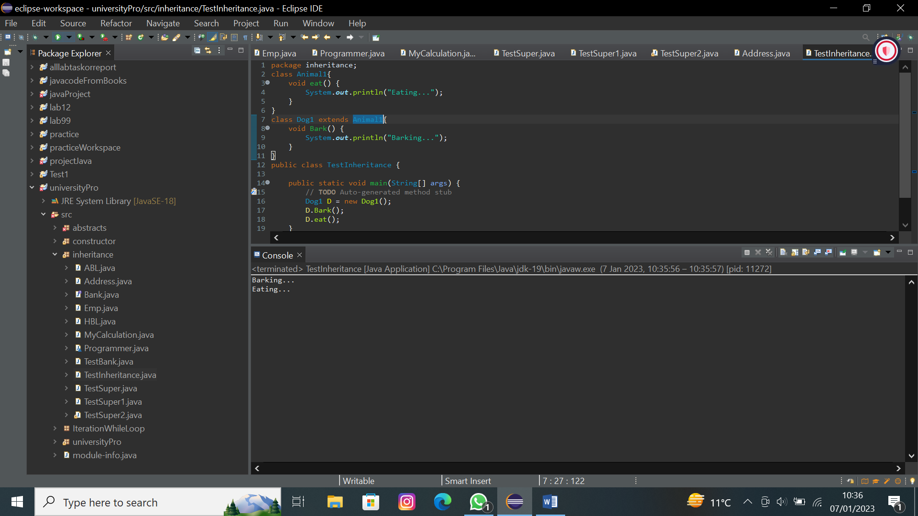
Program 07:-
Multilevel Inheritance Example:
package inheritance;
class Animal2{
void eat() {
System.out.println("Eating...");
}
}
class Dog2 extends Animal2{
void Bark() {
System.out.println("Barking...");
}
}
class BabyDog extends Dog2{
void weep() {
System.out.println("Weeping...");
}
}
public class TestInheritance2 {
public static void main(String[] args) {
// TODO Auto-generated method stub
BabyDog b = new BabyDog();
b.weep();
b.Bark();
b.eat();
}
}
Output:-
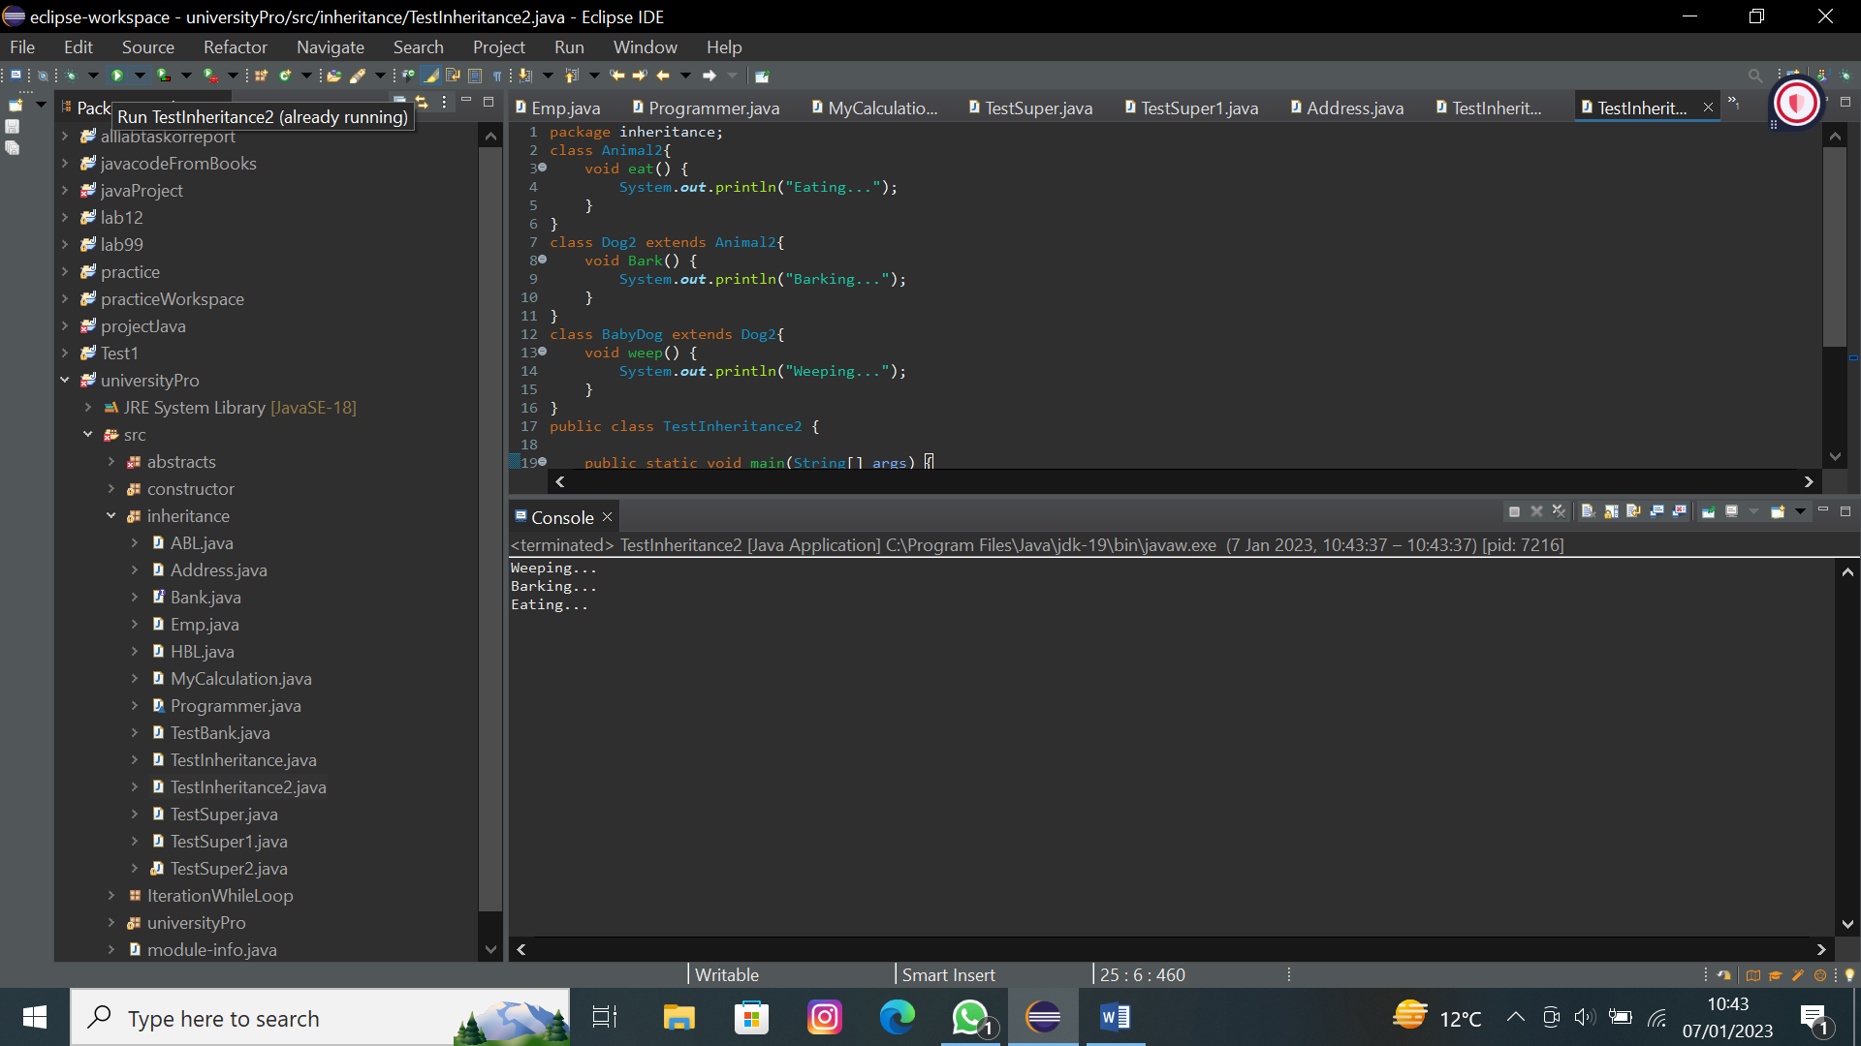
Program 08:-
Hierarchical Inheritance Example:
package inheritance;
class Animal3{
void eat() {
System.out.println("Eating...");
}
}
class Dog3 extends Animal2{
void Bark() {
System.out.println("Barking...");
}
}
class Cat extends Animal3{
void meow() {
System.out.println("Meowing...");
}
}
public class TestInheritance3 {
public static void main(String[] args) {
// TODO Auto-generated method stub
Cat c = new Cat();
c.eat();
c.meow();
//c.Bark();//C.T error
}
}
Output:-
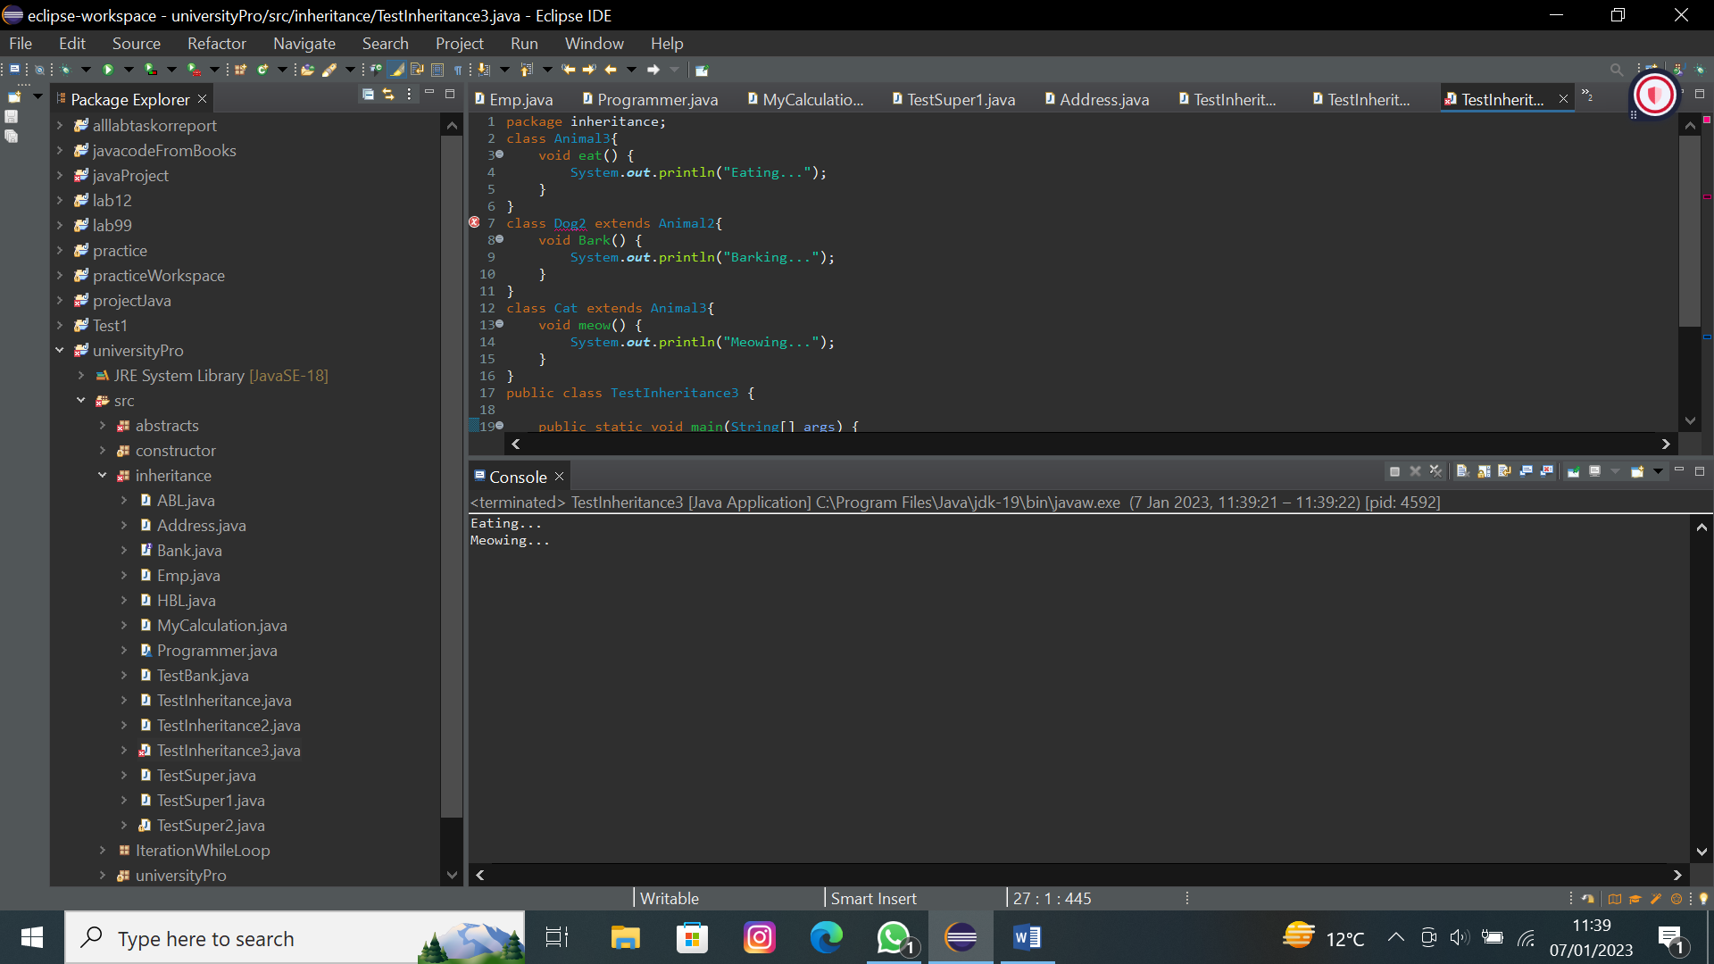

Program 09:-
Why java does not support multiple inheritance?
Multiple inheritance is not supported in Java to reduce the complexity and simplify the language.
package inheritance;
class A{
void message() {
System.out.println("Hello...");
}
}
class B{
void message() {
System.out.println("Wellcome...");
}
}
public class C extends A,B{//suppose if it were
public static void main(String[] args) {
// TODO Auto-generated method stub
C obj = new C();
obj.message();//which message method were invoked
}
}
Program 10:-
package inheritance;
public class Address {
String city,zipcode,country;
public Address(String city,String zipcode,String country) {
this.city=city;
this.zipcode=zipcode;
this.country=country;
}
}
package inheritance;
public class Emp{
String name;
int ID;
Address adderss;
Emp(String name,int ID,Address address)
{
this.name = name;
this.ID=ID;
this.adderss=address;
}
void getData() {
System.out.print(name+" "+ID);
System.out.print(" "+adderss.city+" "+adderss.zipcode+" "+adderss.country);
}
public static void main(String[] args) {
// TODO Auto-generated method stub
Address address1 = new Address("Skardu","123","pakistan");
Address address2 = new Address("Khaplu","124","baltistan");
Emp E1 = new Emp("Burhan",12,address1);
Emp E2 = new Emp("Sajid",13,address2);
E1.getData();
E2.getData();
}
}

Output:-
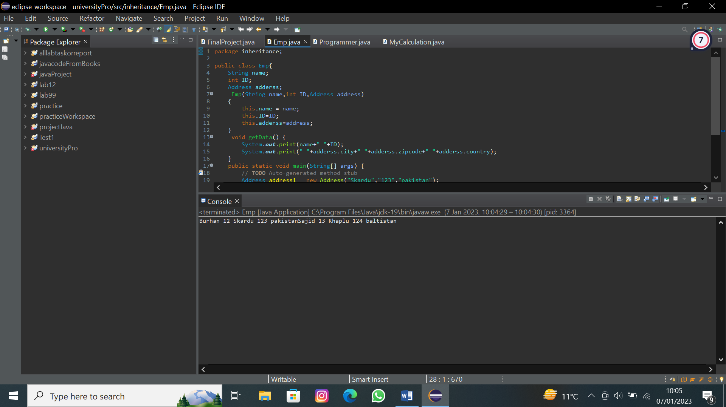
Program 11:-
package inheritance;
public class Bank {
public double intrest() {
return 0;
}
}
package inheritance;
public class HBL extends Bank{
@Override
public double intrest() {
// TODO Auto-generated method stub
return 7;
}
}
package inheritance;
public class ABL extends Bank{
@Override
public double intrest() {
// TODO Auto-generated method stub
return 7.5;
}
}
package inheritance;
public class TestBank {
public static void main(String[] args) {
// TODO Auto-generated method stub
HBL b = new HBL();
System.out.println("HBL Provide intrest of "+b.intrest());
Bank b1 = new ABL();
System.out.println("HBL Provide intrest of "+b1.intrest()); }
}
Output:-
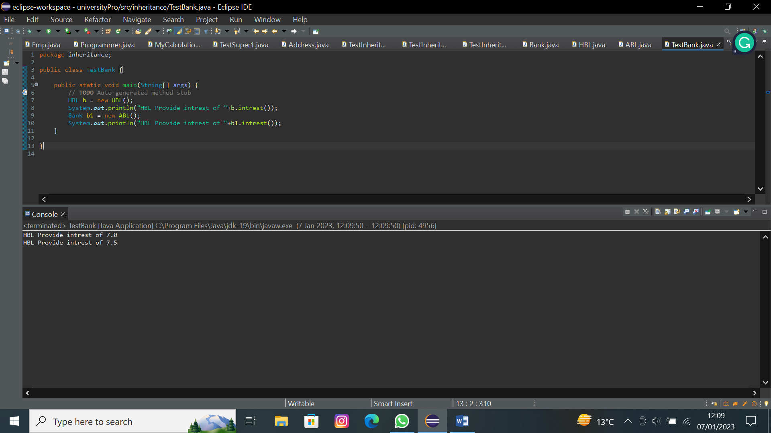

Lab 10
Program 1:-
package JavaInterface;
//defining an interface
public interface Printable {
void print();
}
package JavaInterface;
//implementing interfaces
public class InterfaceExp implements Printable{
public static void main(String[] args) {
// TODO Auto-generated method stub
Printable obj=new InterfaceExp();
obj.print();
}

@Override
public void print() {
// TODO Auto-generated method stub
System.out.println("Printing");
}
}

Output:-
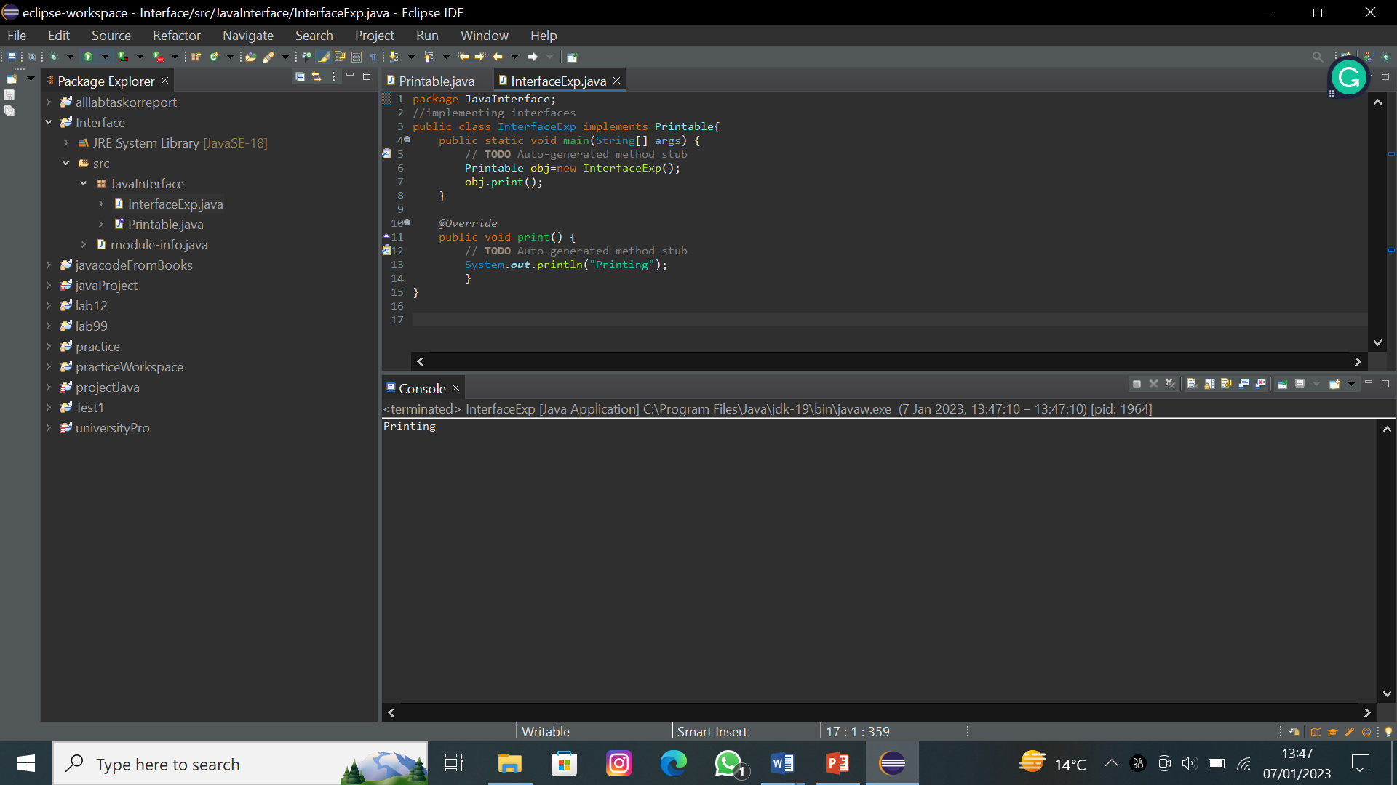
Program 2:-
package JavaInterface;
public interface Printable {
void print();
}
package JavaInterface;
//implementing interfaces
public class InterfaceExp implements Printable{
public static void main(String[] args) {
// TODO Auto-generated method stub
Printable obj=new InterfaceExp();
obj.print();
}

@Override
public void print() {
// TODO Auto-generated method stub
System.out.println("another way to implement interface");
System.out.println("Printing"); }
}
Output:-
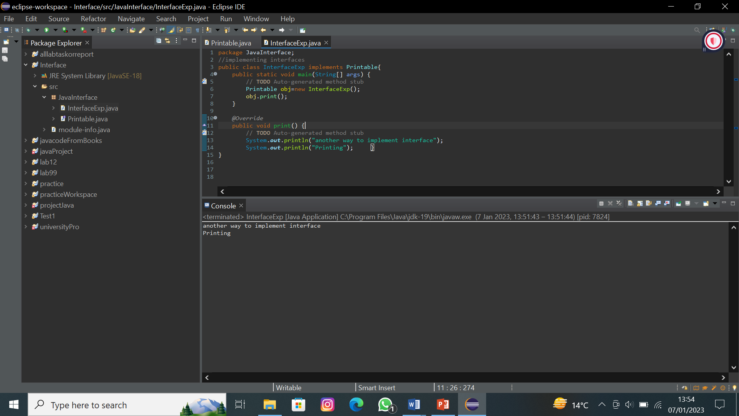
Program 3:-
package JavaInterface;
public interface Drawable {
void draw();
}
package JavaInterface;
public class Rectangle implements Drawable {
public void draw()
{
System.out.println("drawing rectangle");
}
}
package JavaInterface;
public class Circle implements Drawable{
public void draw()
{
System.out.println("drawing circle");
}
}
package JavaInterface;
public class TestInterface {
public static void main(String[] args) {
Drawable d;
d=new Circle();
d.draw();
d=new Rectangle();
d.draw();
}
}
Output:-
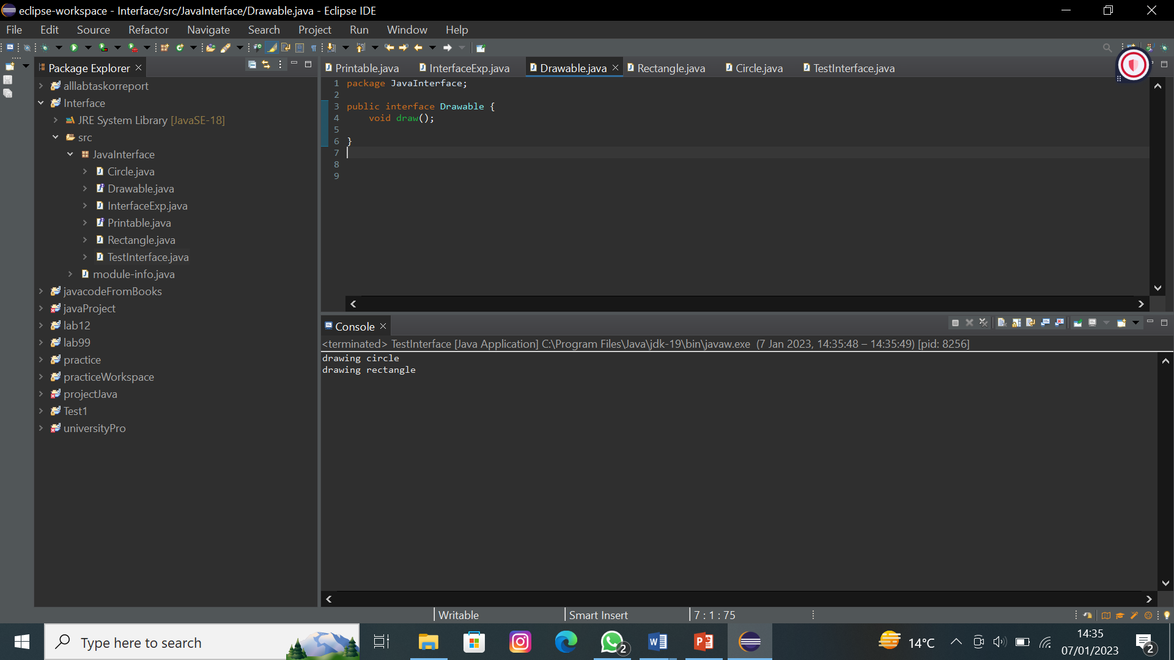
Program 4:-

package JavaInterface;
public interface Drawable {
void draw();

default void msg()
{
System.out.println("default method");
}
}
package JavaInterface;
public class Rectangle implements Drawable {
public void draw()
{
System.out.println("drawing rectangle");
}
}
package JavaInterface;
public class TestInterface {
public static void main(String[] args) {
Drawable d=new Rectangle();
d.draw();
d.msg();
}
}
Output:-
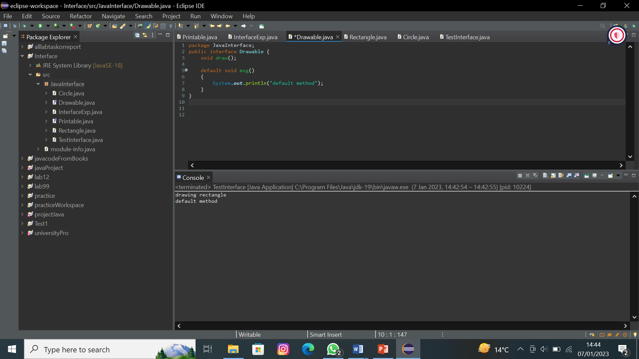
Program 5:-
package JavaInterface;
public interface Add {
void Addition(double a,double b);
}
interface Sub{
void Subtraction(double a,double b);
}
interface MulDiv extends Sub{
void Multiplication(double a,double b); void Division(double a,double b);
}
package JavaInterface;
public class AllCalculation implements Add, MulDiv { public void Addition(double a,double b)
{
System.out.println(a+b);
}
public void Subtraction(double a,double b)
{
System.out.println(a-b);
}
public void Division(double a,double b)
{
System.out.println(a/b);
}
public void Multiplication(double a,double b)
{
System.out.println(a*b);
}
public static void main(String args[])
{
AllCalculation ob1=new AllCalculation(); ob1.Addition(3, 3);
ob1.Subtraction(3, 4);
ob1.Division(3, 5);
ob1.Multiplication(3, 2);
}
}
Output:-
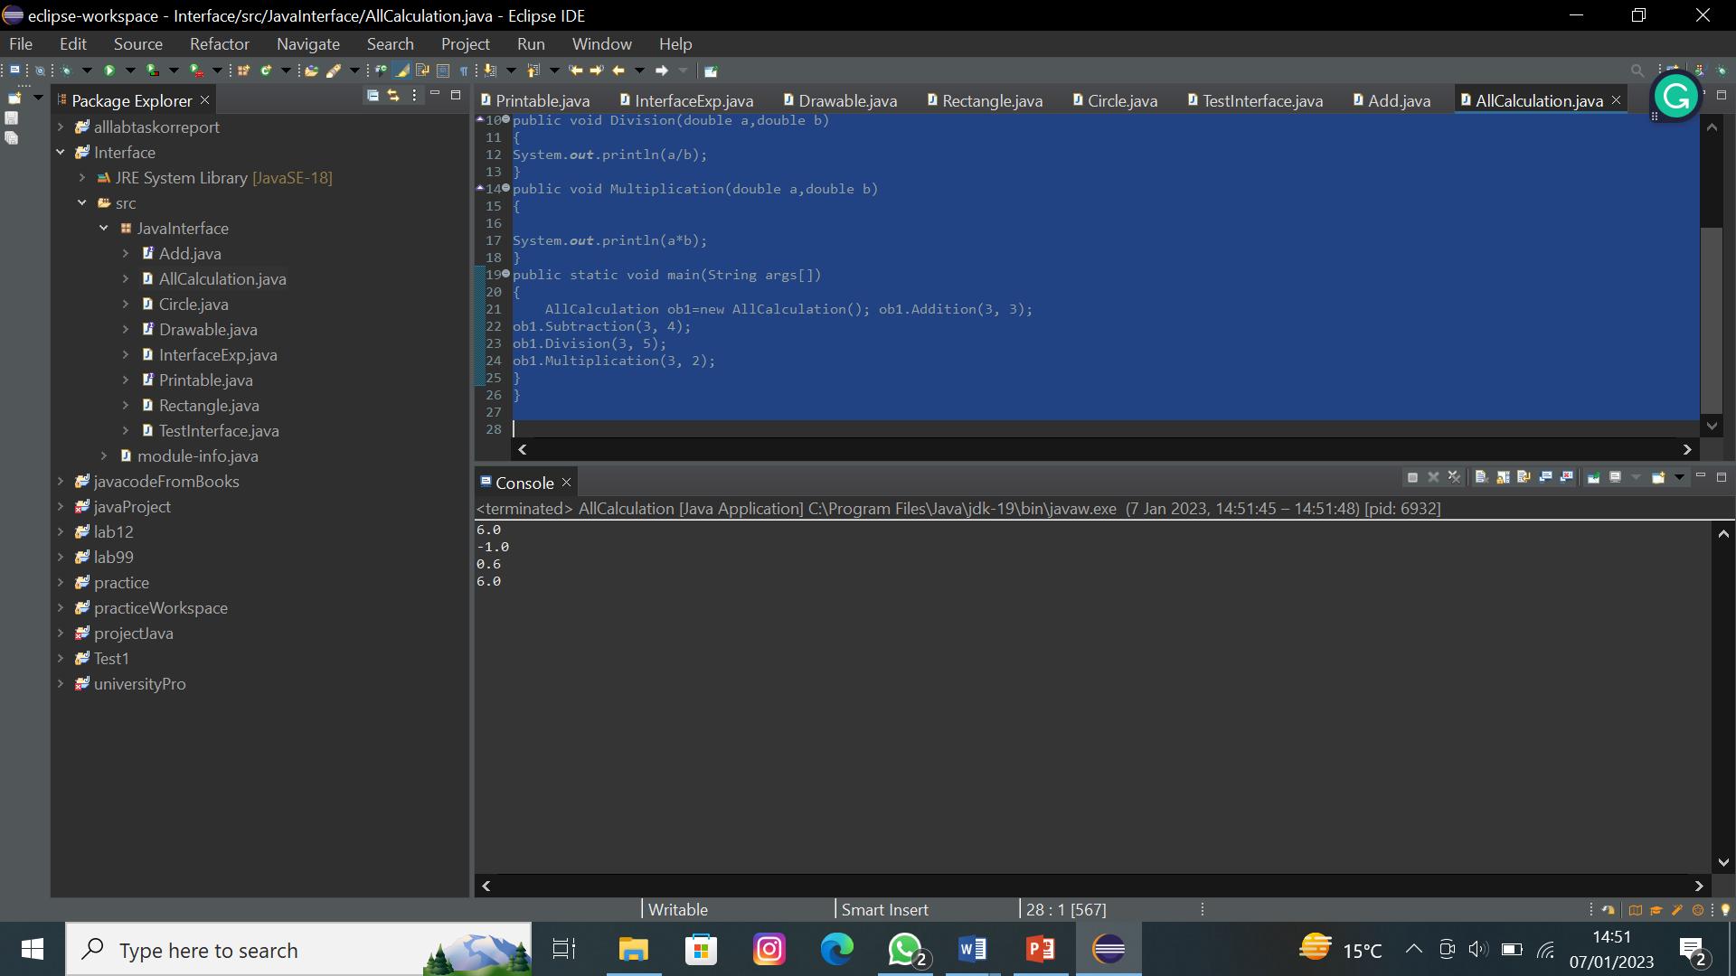
Program 6:-
package JavaInterface;
public interface One {
int x=12;
}
interface two { int y=10;
void display();
}
package JavaInterface;
public class Addition implements One, two {
public void display()
{
System.out.println(x); System.out.println(y); System.out.println(x+y);
}
public static void main(String args[]){
Addition obj1= new Addition(); obj1.display();
}
}
Output:-
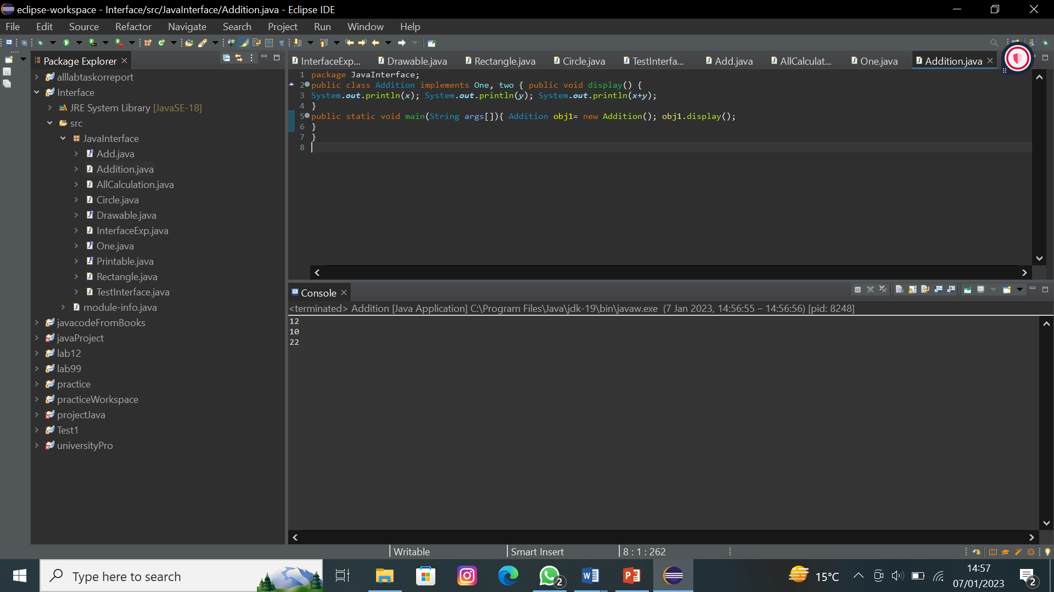
Program 7:-
package JavaInterface;
public interface Bank
{
void rateOfInterest();
}
package JavaInterface;
class HBL implements Bank{ public void rateOfInterest()
{
System.out.println("Rate of Interest is 7 percent in HBL bank ");
}
}
package JavaInterface;
class ABL implements Bank {
public void rateOfInterest()
{
System.out.println("Rate of Interest is 7 percent in ABL bank ");
}
}
package JavaInterface;
public class Print {
public static void main(String args[])
{
Bank ob1= new HBL();
Bank ob2= new ABL();
ob1.rateOfInterest();
ob2.rateOfInterest();
}
}
Output:-
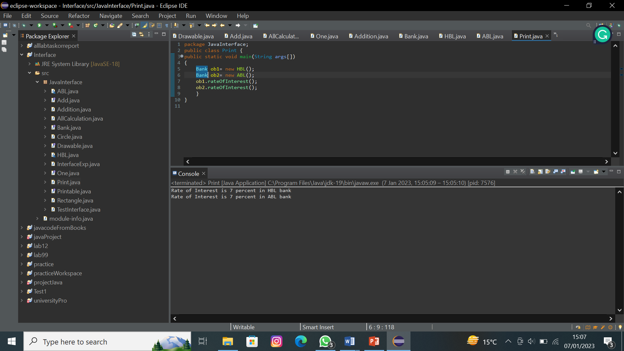
Lab No.11
Program 01:-
package lab12AWT;
import java.awt.*;
import java.awt.event.*;

public class AEvent extends Frame implements ActionListener {
TextField tf;
Button b;
AEvent(){
tf = new TextField();
tf.setBounds(60, 50, 170, 20);
b = new Button("Click Here");
b.setBounds(100, 120, 80, 30);
b.addActionListener(this);
add(b);
add(tf);
setSize(300,300);
setLayout(null);
setVisible(true);
addWindowListener(new WindowAdapter() {
public void windowClosing(WindowEvent windowEvent) {
System.exit(0);
}
});
}
public static void main(String[] args) {
// TODO Auto-generated method stub
new AEvent();
}
@Override
public void actionPerformed(ActionEvent e) {
// TODO Auto-generated method stub
tf.setText("WellCome");
}
}
Output:-
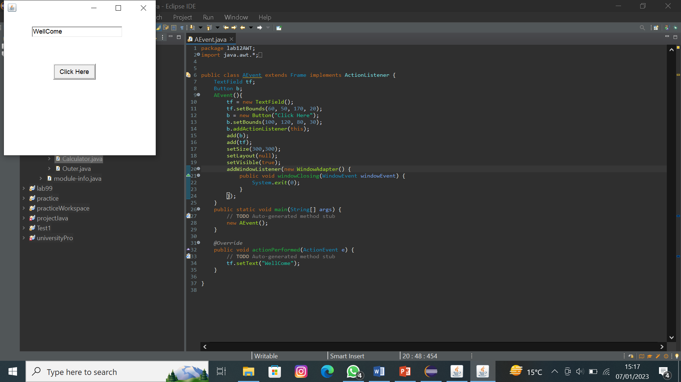
Program 02:-
package lab12AWT;
import java.awt.Button;
import java.awt.Frame;
import java.awt.TextField;
public class AEvent2 extends Frame{
TextField tf;
Button b;
public AEvent2() {
tf= new TextField();
tf.setBounds(60, 50, 170, 20);
b = new Button("Click Me");
b.setBounds(100, 120, 80, 30);
Outer o = new Outer(this);
b.addActionListener(o);
add(tf);
add(b);
setSize(300,300);
setLayout(null);
setVisible(true);
}
public static void main(String args[]) {
new AEvent2();
}
}
Output:-
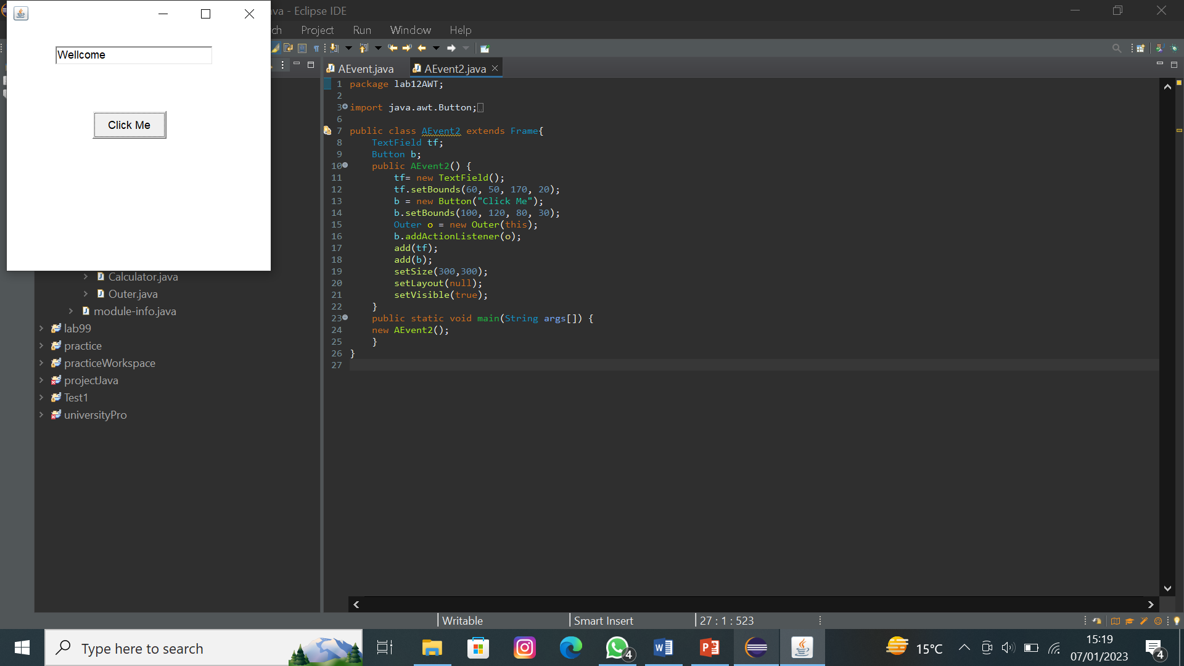
Program 03:-
package lab12AWT;
import java.awt.*;
import java.awt.event.ActionEvent;
import java.awt.event.ActionListener;
import java.awt.event.WindowAdapter;
import java.awt.event.WindowEvent;
public class AEvent3 {
TextField tf;
Frame f;
AEvent3(){
f = new Frame("The Anonymous class of Frame is");
tf =new TextField();
tf.setBounds(60,50,170,20);
Button b = new Button("Click Me");
b.setBounds(100, 100,80,30);
b.addActionListener(new ActionListener() {
public void actionPerformed(ActionEvent e) {
tf.setText("Hello");
}
});
f.add(b);
f.add(tf);
f.setSize(300,300);
f.setVisible(true);
f.setLayout(null);
f.addWindowListener(new WindowAdapter() {
public void windowClosing(WindowEvent windowEvent) {
System.exit(0);
}
});
}
public static void main(String[] args) {
// TODO Auto-generated method stub
new AEvent3();
}
}
Output:-
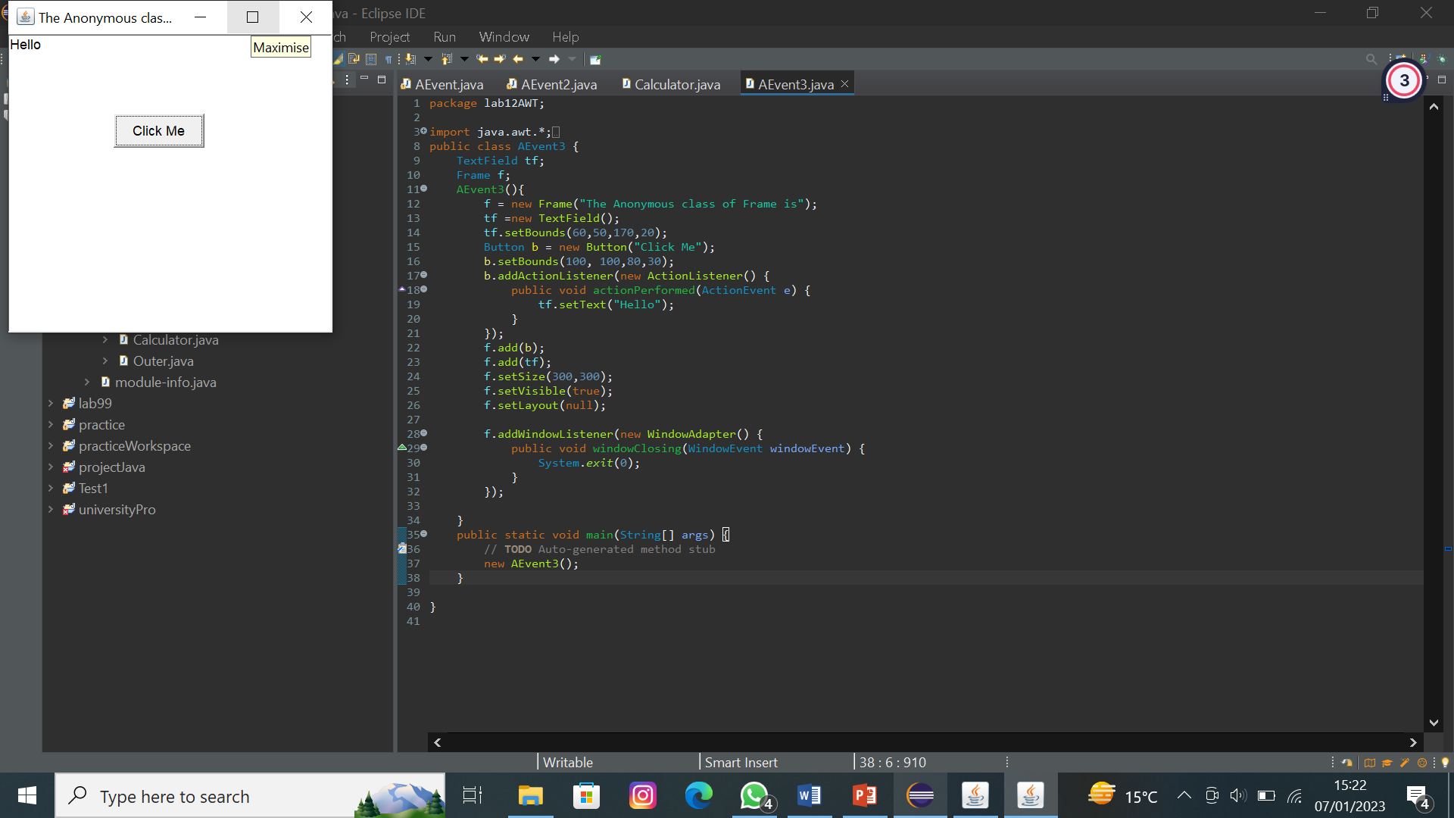
Program 04:-
import javax.swing.*;
import java.awt.event.*;
public class calculator1 implements ActionListener {
JFrame f;
JTextField tf1,tf2,tf3;
JLabel l1 ,l2 ,l3;
JButton b1,b2,b3,b4,b5,b6;
calculator1(){
JFrame f=new JFrame();
l1=new JLabel("Enter First Number");
l1.setBounds(50,30,150,20);
tf1=new JTextField();
tf1.setBounds(50,50,150,20);
l2=new JLabel("Enter Second Number");
l2.setBounds(50,80,150,20);
tf2=new JTextField();
tf2.setBounds(50,100,150,20);
l3=new JLabel("Result");
l3.setBounds(50,130,150,20);
tf3=new JTextField();
tf3.setBounds(50,150,150,20);
tf3.setEditable(false);
b1 = new JButton("+");
b1.setBounds(50,200,50,50);
b2 = new JButton("-");
b2.setBounds(150,200,50,50);
b3 = new JButton("*");
b3.setBounds(50,300,50,50);
b4 = new JButton("/");
b4.setBounds(150,300,50,50);
b5 = new JButton("Clear");
b5.setBounds(150,400,100,50);
b6 = new JButton("%");
b6.setBounds(50,400,50,50);
b1.addActionListener(this);
b2.addActionListener(this);
b3.addActionListener(this);
b4.addActionListener(this);
b5.addActionListener(this);
b6.addActionListener(this);
f.add(tf1);f.add(tf2);f.add(tf3); f.add(l1);f.add(l2);f.add(l3);f.add(b1);f.add(b2);f.add(b3);f.add(b4);f.add(b5);f.add(b6);f.setSize(300,300);f.setLayout(null);
f.setVisible(true) ;
}
public void actionPerformed(ActionEvent e) {
// TODO Auto-generated method stub
String s1=tf1.getText();
String s2=tf2.getText();
int a =Integer.parseInt(s1);
int b =Integer.parseInt(s2);
int c=0;
if(e.getSource()==b1) {
c=a+b;
JOptionPane.showMessageDialog(f,"addition of two number = "+c);
}
else if(e.getSource()==b2) {
c=a-b;
JOptionPane.showMessageDialog(f,"Subtraction of two number = "+c); }
else if(e.getSource()==b3) {
c=a*b;JOptionPane.showMessageDialog(f,"Product of two number = "+c);}
else if(e.getSource()==b4) {
c=a/b;
JOptionPane.showMessageDialog(f,"Division of two number = "+c);}
else if(e.getSource()==b5) {
c=0;
}
else if(e.getSource()==b6) {
c=a%b;
JOptionPane.showMessageDialog(f,"Division of two number = "+c);}
String result= String.valueOf(c);
tf3.setText(result);
}
public static void main(String[] args) {
// TODO Auto-generated method stub
new calculator1();
}
}
Output:-
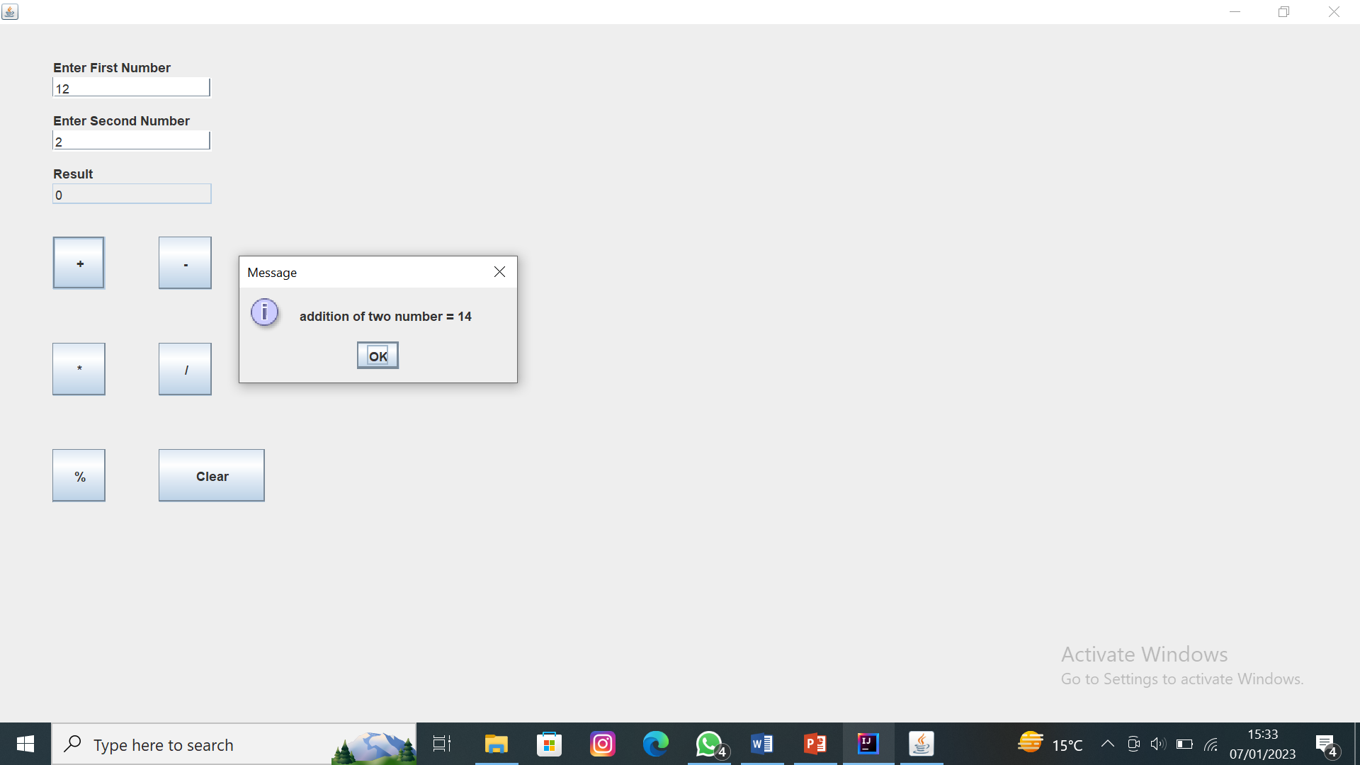

Program 04:-
import javax.swing.*;
import java.awt.event.*;
public class SignUp implements ActionListener {
JFrame f,info;
JTextField t,t1,t2,t3,t4,t5;
JLabel l,l1,l2,l3,l4,l5,l6,l7,l8,l9,l10,l11;
JButton b;
JRadioButton r1,r2;
JTextArea ta,ta2;
JCheckBox c;
ButtonGroup g;
JPasswordField p;
SignUp(){
f=new JFrame("SignUp");
l=new JLabel("''''SignUp Page''''");
l.setBounds(145,20,150,20);
f.add(l);
l1=new JLabel("First Name :");
l1.setBounds(50,50,100,20);
f.add(l1);
t=new JTextField();
t.setBounds(150,50,200,20);
f.add(t);
l2=new JLabel("Last Name :");
l2.setBounds(50,85,100,20);
f.add(l2);
t1=new JTextField();
t1.setBounds(150,85,200,20);
f.add(t1);
l3=new JLabel("Email :");
l3.setBounds(50,125,100,20);
f.add(l3);
t2=new JTextField();
t2.setBounds(150,125,200,20);
f.add(t2);
l4=new JLabel("Password :");
l4.setBounds(50,160,100,20);
f.add(l4);
p=new JPasswordField();
p.setBounds(150,160,200,20);
f.add(p);
l5=new JLabel("Gender :");
l5.setBounds(50,200,100,20);
f.add(l5);
r1=new JRadioButton("Male");
r1.setBounds(150,200,100,20);
f.add(r1);
r2=new JRadioButton("Female");
r2.setBounds(150,230,100,20);
f.add(r2);
g=new ButtonGroup();
g.add(r1);
g.add(r2);
l6=new JLabel("Address :");
l6.setBounds(50,265,100,20);
f.add(l6);
ta=new JTextArea();
ta.setBounds(150,265,200,100);
f.add(ta);
c=new JCheckBox("I accept the terms and conditions");
c.setBounds(50,400,250,20);
f.add(c);
b=new JButton("SignUp");
b.setBounds(180,435,80,80);
f.add(b);
b.addActionListener(this);
f.setSize(400,600);
f.setLayout(null);
f.setVisible(true);
}
public void actionPerformed(ActionEvent e) {
info =new JFrame();
l7=new JLabel("''''Welcome''''");
l7.setBounds(145,20,150,20);
info.add(l7);
String s=t.getText();
String s1=t1.getText();
String s2=t2.getText();
String s4=ta.getText();
l8=new JLabel("First Name :");
l8.setBounds(50,50,100,20);
info.add(l8);
t3=new JTextField();
t3.setBounds(150,50,200,20);
info.add(t3);
t3.setEditable(false);
t3.setText(s);
l9=new JLabel("Last Name :");
l9.setBounds(50,85,100,20);
info.add(l9);
t4=new JTextField();
t4.setBounds(150,85,200,20);
info.add(t4);
t4.setEditable(false);
t4.setText(s1);
l10=new JLabel("Email is :");
l10.setBounds(50,125,100,20);
info.add(l10);
t5=new JTextField();
t5.setBounds(150,125,200,20);
info.add(t5);
t5.setEditable(false);
t5.setText(s2);
l11=new JLabel("Address is :");
l11.setBounds(50,265,100,20);
info.add(l11);
ta2=new JTextArea();
ta2.setBounds(150,265,200,50);
info.add(ta2);
ta2.setEditable(false);
ta2.setText(s4);
info.setSize(400,400);
info.setLayout(null);
f.dispose();
info.setVisible(true);
}
public static void main(String[] args) {
new SignUp();
}
}
Output:-
